Wigton Motor Club Ltd

Present the
Cumbria Classic & Motorsport Show
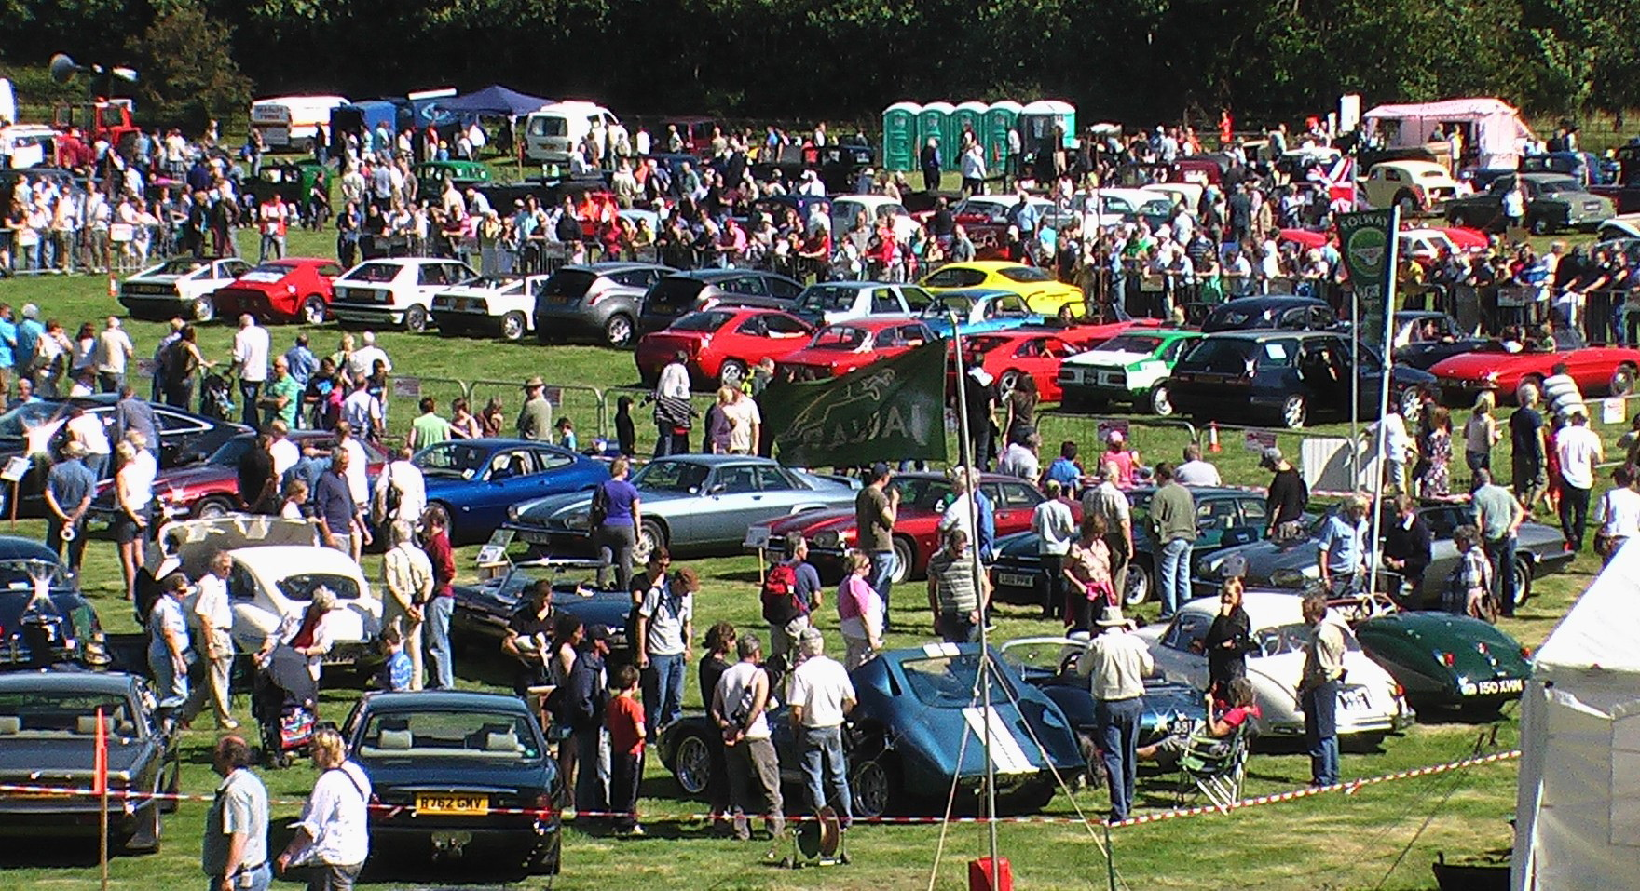

Sunday, August 18th

Dalemain

Near Ullswater
On the A592
Supporting local charities

Club Entry Form

WIGTON MOTOR CLUB

CUMBRIA CLASSIC WEEKEND 2024

Club Displays

Welcome to the thirty third Cumbria Classic Weekend which this year takes place over the weekend of August 19/20th. We are repeating our successful format with a package of two events, which we hope will encourage you to stay in the Lake District and in the beautiful district of Eden in particular.

The Rose and Thistle Tour takes place on Saturday and visits some of the most interesting roads in England and Scotland. Sunday sees the Cumbria Classic Car Show staged in the spectacular setting of Dalemain by Ullswater

As well as the usual club stands, autojumble, and hundreds of cars we will have arena action, autotests, motorsport display, a trade area, craft stalls, entertainment and toy and produce stalls.

This year we celebrate French and German cars and we welcome clubs with hose makes.

The £5 entry fee will admit two people to the show, a superb limited edition attendance award to a total worth of £26!! Wigton MC members will be able to enter their car free of charge as long as they quote their membership number.

The closing date for entries is firm and no entries will be accepted on the day under any circumstances. This year we are capping the total number of entries at 800 split equally between club displays and individual entries.

Final instructions and passes will be posted out a week before the event.

Camping: Due to the demand from entrants who wish to camp we can offer pre booked camping permits for £20 per unit, per night. You can camp only on the Saturday night. Camping must be paid with your entry fee. Camping is only permitted for vehicle entrants. This fee is set by the land owner.

“No Shows” In common with all other shows there are too many people who enter and then fail to turn up leaving gaps on the field. We appreciate that there are reasons for being unable to come, such as illness or mechanical issues, but it is courteous to phone the entries secretary to let them know. Failure to turn up , or not informing us in advance, could lead to your entry being refused in future years.

Accommodation:
Penrith TIC: 01768 867466 or email pen.tic@eden.gov.uk

We look forward to seeing you in August but do please remember that all the events fill up very quickly!

Contacts:
Cumbria Classic Show Club entries John Holliday 01228 561251
Cumbria Classic Show car entries John Graham 01228 534483
Rose & Thistle Challenge Ron Palmer 01228 575153
General Graeme Forrester gtfmg@yahoo.co.uk

Please only ring officials between 1800 and 2100, (We do like to have a few hours away from the event!)

Unfortunately, this year we are not allowing 4x4 vehicles on the autotest.

At the conclusion of the show you are asked to drive considerately as you leave. Anyone seen driving over enthusiastically will be banned from future events.

We look forward to seeing you in August but do please remember that all the events fill up very quickly! We do not accept entries after the closing date on August 1st and there will be no additional entries allowed on the day UNDER ANY CIRCUMSTANCES.

Please return the attached form by July 20th at the latest.

Cumbria Classic Show 2023

CLUB DISPLAY ENTRY

Club name:

Display Co-ordinator:

Address:

Post Code: Telephone:

Email:_______________________________________________________

Number of cars entered:_________________

Entry fees
Entry fee per vehicle £5 | £
Camping permit £20 per unit per night | £
Total | £ :00

Please ensure that the form is fully completed before posting.

Please return this form to John Holliday, 11 Cairn Crescent, Corby Hill,
Carlisle. CA4 8QH, or by email: johnholl403@gmail.com; by July 20th , by cash which saves us paying bank charges, or by BACS , with your club as the reference. HSBC Sort Code 40.34.18 Account 44669770 .

Interested in motorsport and classic cars?
Only one club can offer you the following: -

A full programme of events including: autotests, autosolos, production car autotests, historic rallies, classic car events, pub runs and a lively social scene.
Cars & Coffee at the Motor House each month
The Cumbria Classic Weekend.
The Rose & Thistle Classic Tour.
The Historic Rally Challenge.
The White Heather Historic &Targa Rally
The Solway Historic Rally
The Gallop weekend touring event
A professional standard monthly magazine: Start Line
A marshals’ championship
Advice from experts in all aspects of Motorsport.
A web site packed with information
Training courses for marshals and competitors.
Novice rally instruction.
Monthly summer pub runs

WIGTON MOTOR CLUB LTD

THE NORTH'S BIGGEST MOTOR CLUB !
1000 members

Go to www.wigtonmc.co.uk

See our Face Book page Wigton Motor Club

