Wigton Motor Club
‘Firth to Forth’
Friday 17th June 2022
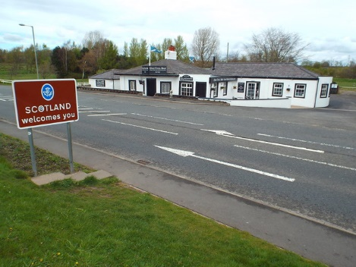

Regulations
And
Entry Form
A Coast to Coast Touring Event

